Tharindu Wijayarathna

tharinuwijayarathne87@gmail.com

REDOX LMS System

Project Documentation

**LEARNING MANAGEMENT SYSTEMS (LMS)**

**Module Structure**

1. Learning Outcomes
2. Introduction to LMS
3. Background / History of LMS
4. Concept of LMS
5. Components of LMS
6. Characteristics of LMS
7. UI Interface

**Learning Outcomes**

1. After going through this module, the learner will be able to:
2. Acquire knowledge about the concept of learning management systems.
3. Develop an understanding of the various components of the learning management systems in detail.
4. Develop an understanding of the various advantages of the learning management Systems.
5. Develop an understanding of the few limitations of the learning management systems.
6. Be aware of the applications of the learning management systems in the current scenario.

**Introduction**

A LMS is a web-based software solution to simplify the administration of learning program. It can track learner progress through a learning program, provide a forum for collaborating, centralize program information and scheduling, provide a platform for synchronous and asynchronous courseware and enable the assessment of learning effectiveness

**Background**

Earlier learning took place in a chalk and talk method with the teacher-centric education. Then with the infusion of technology in education, there was a paradigm shift in the way learning experiences were provided to the students. The most recent trend in patterns on learning is e-learning, i.e. technologyenhanced education. Learning program and materials are hosted and available online, allowing students to learn, interact and even earn or obtain degrees sitting in the comfort of their own homes. Even though the internet allows for hosting the learning material, the challenges of maintaining and administering the instructions over the internet is also to be difficult. Hence, Learning Management Systems (LMS) or the software designed to aid organizations/institutions in managing their e-learning initiatives have mushroomed and there is a huge market for the same.

**Concept of LMS**

LMS embraces any use of web technology to plan, organize, implement and control aspects of the learning process. The most comprehensive description has been given by Greenberg (2002): a high level, strategic solution for planning, delivering and managing all learning events within an organization, including online, virtual classroom, and instructor-led courses.

So, basically an LMS is a software application for the administration, documentation, tracking, reporting and delivery of e-learning education courses or training programs.

LMSs range from systems for managing training and educational records to software for distributing online or blended/hybrid college courses over the Internet with features for online collaboration. Colleges and universities use LMSs to deliver online courses and compliment on-campus courses. Corporate training departments use LMSs to deliver online training, as well as automate record-keeping and employee registration.

In educational setting, adoption of LMS has a wide scope. Universities are seeing distance education as the means to the future. It is also seen as a way to decrease costs, decrease the need for classrooms, increase access to education and increase their student population. Instructors also find the use of LMS actually improves their teaching. (Ehrman & Gilbert, 2003)

LMS not only delivers content but also handles registering for courses, course administration, skills gap analysis, tracking, and reporting.

**Components / features of LMS**

Since most organizations tend to customize the LMS according to their needs, the typical features are difficult to list out, but the most common features of LMS are:

* Portal Payments
* Material Sharing
* Assignment checking
* Marks delivery
* View answer sheets
* Block users
* Check student results
* Reports
* Profile management
* Student tracking
* Administrative tools

An effective LMS performs the functions of creating class rosters, controlling registration and creating waiting lists, uploading and managing documents containing curriculum content, delivering course content over a Web-based interface, allowing for an entirely remote educational experience for the instructor and forums, to establishing methods for assessment and testing, such as multiple choice quizzes.

**Characteristics of LMS**

* Structure – It should have a proper structure with centralization and organization of all learning-related functions into one system which would enable navigation easy and effective.
* Security – The learning management system should be able to protect from unauthorized access to courses, student records, and administrative functions.
* Registration – It should help in finding and selecting or assigning courses, curricula, etc. by learners and their supervisors, which would also include instructor-led training classes.
* Delivery – It should be able to provide smooth delivery of content, on-demand delivery of learning content and experiences to learners.
* Assessment – It should enable administering assessments and the collection, tracking, and storing of assessment data, with further actions taken based on the results of assessment. Many LMSs include the ability to create assessments as well.
* Reporting – It should enable extraction and presentation of information by administrators and stakeholders about learners and courses, including the information that is tracked as described above.
* Record keeping – It should also have provision for storage and maintenance of data about learners. This includes both demographical information profiling learners and their training progress and accomplishments. This is especially critical when an LMS is deployed as the official system of record for an organization.
* Personalization – It should enable configuration of LMS functions, interfaces, and features by learners and administrators to match personal preferences, organizational needs, etc.
* Administration – Above all, it should be able to centrally manage all of the functions which are listed above.

**UI Interface**

Users can login to their accounts according to their account type

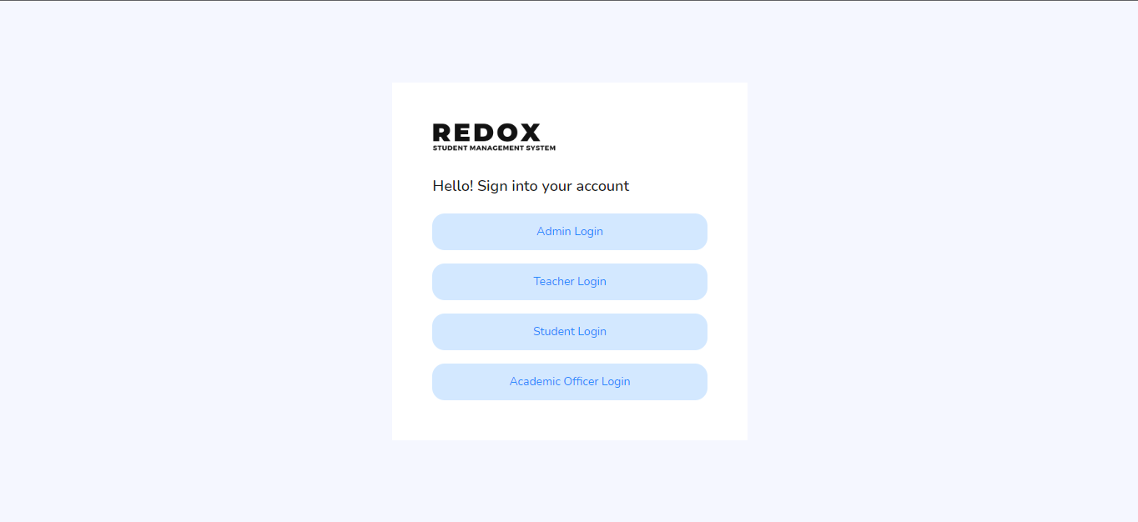

User has this type of login screens to log into their dashboard

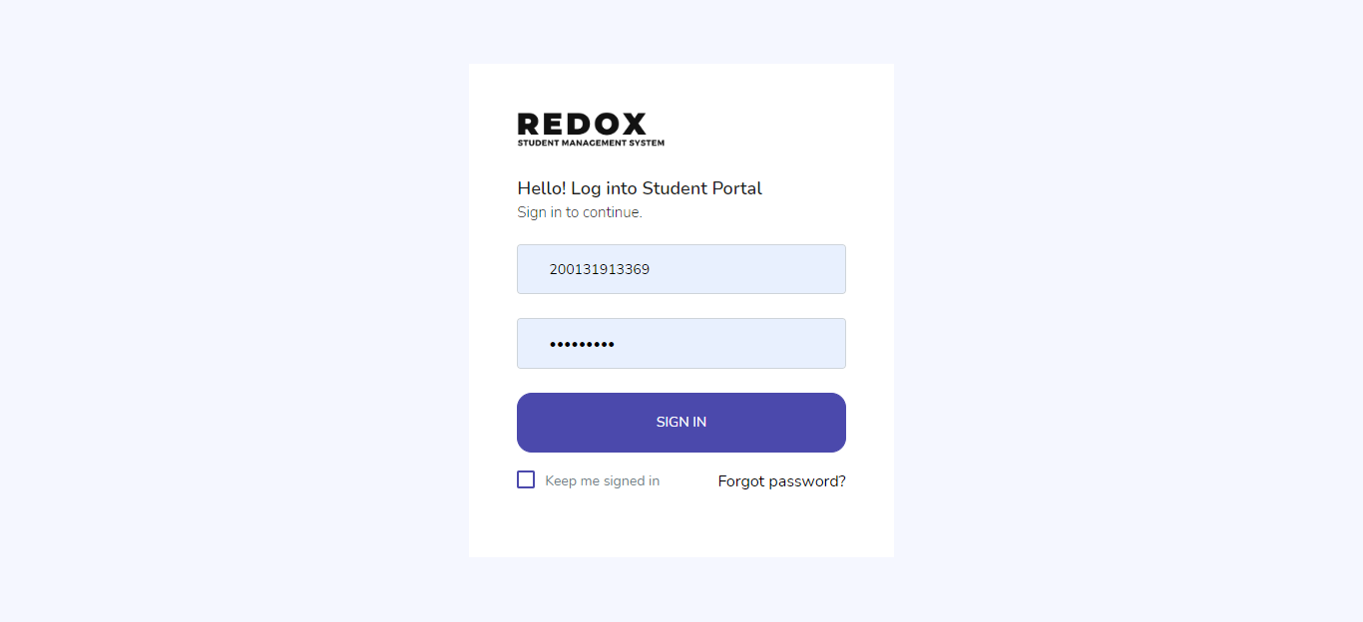

Student Dashboard

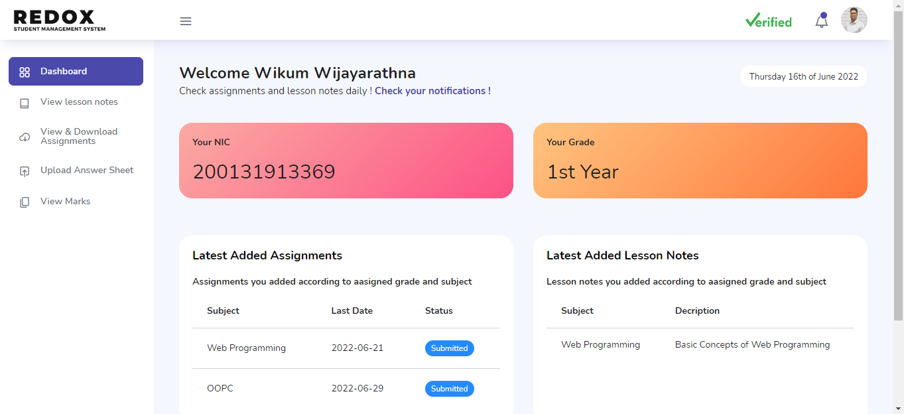

Admin Dashboard

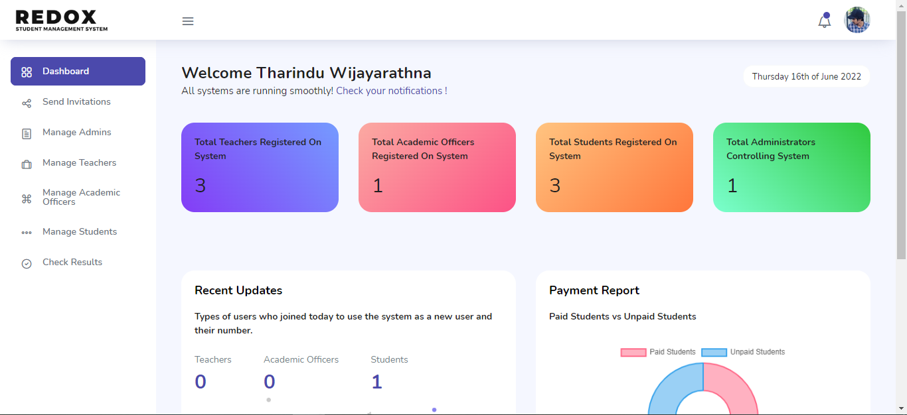

Academic officer dashboard

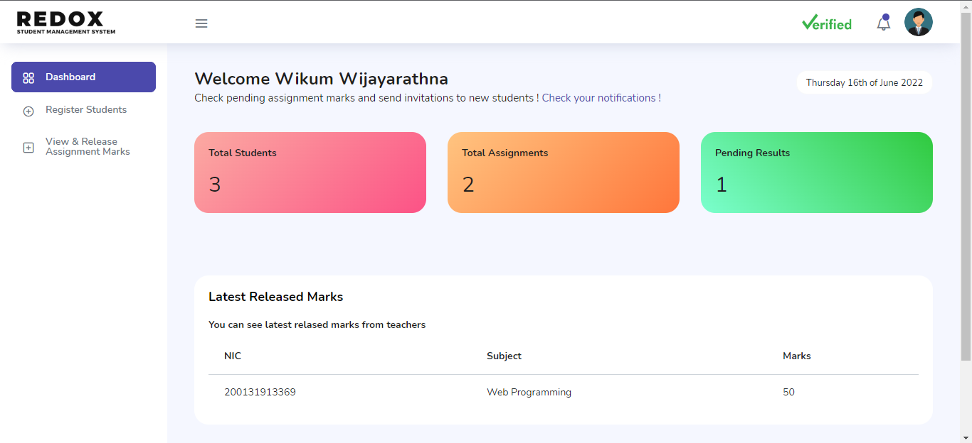

Teachers Dashboard

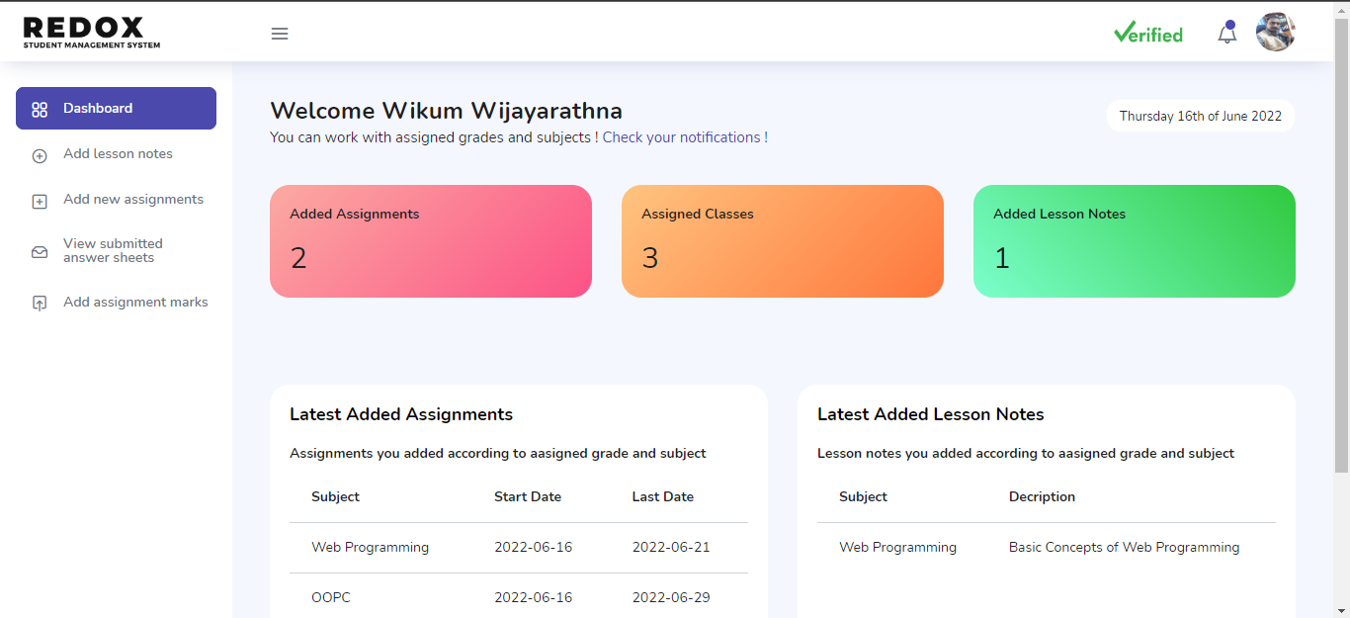

Update profile option for all users

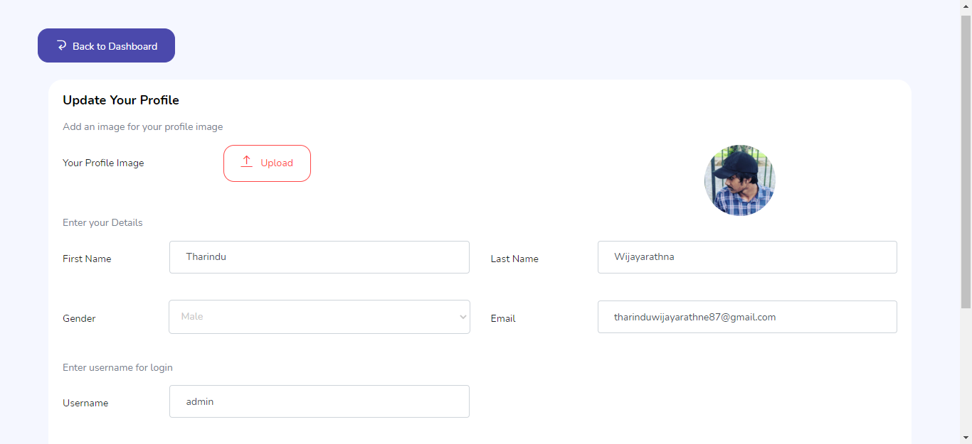

The implementation of a learning management system is an important tool for online learning. Along with online courses, many schools use their LMS to enroll students in classroom-based events, and generate reports on student’s progress.

REDOX LMS SYSTEMS (2022)